

PDR

AI for Society



Tony Jiang

Table of Contents

Introduction 4

Individual Project 4

Group Project 4

Learning Outcome 1 Societal Impact 4

First Evaluation: week 4 5

Self-assessment 5

Feedback Evidence 5

Second Evaluation: week 8 6

Self-assessment 6

Feedback Evidence 7

Third Evaluation: week 12 7

Self-assessment 7

Feedback Evidence 8

Learning Outcome 2 investigative Problem Solving 8

First Evaluation: week 4 8

Self-assessment 8

Feedback Evidence 9

Second Evaluation: week 8 9

Self-assessment 9

Feedback Evidence 9

Third Evaluation: week 12 10

Self-assessment 10

Feedback Evidence 10

Learning Outcome 3 Data Preparation 13

First Evaluation: week 4 13

Self-assessment 13

Feedback Evidence 14

Second Evaluation: week 8 14

Self-assessment 14

Feedback Evidence 15

Third Evaluation: week 12 17

Self-assessment 17

Feedback Evidence 17

Learning Outcome 4 Machine Teaching 19

First Evaluation: week 4 20

Self-assessment 20

Feedback Evidence 20

Second Evaluation: week 8 20

Self-assessment 20

Feedback Evidence 20

Third Evaluation: week 12 21

Self-assessment 21

Feedback Evidence 21

Learning Outcome 5 Data Visualisation 23

First Evaluation: week 4 24

Self-assessment 24

Feedback Evidence 24

Second Evaluation: week 8 24

Self-assessment 24

Feedback Evidence 24

Third Evaluation: week 12 25

Self-assessment 25

Feedback Evidence 25

Learning Outcome 6 Reporting 28

First Evaluation: week 4 28

Self-assessment 28

Feedback Evidence 28

Second Evaluation: week 8 29

Self-assessment 29

Feedback Evidence 30

Third Evaluation: week 12 31

Self-assessment 31

Feedback Evidence 31

Learning Outcome 7 Personal Leadership 32

First Evaluation: week 4 32

Self-assessment 32

Feedback Evidence 32

Second Evaluation: week 8 35

Self-assessment 35

Feedback Evidence 35

Third Evaluation: week 12 38

Self-assessment 38

Feedback Evidence 39

Learning Outcome 8 Personal Goal 43

First Evaluation: week 4 43

Self-assessment 43

Feedback Evidence 43

Second Evaluation: week 8 44

Self-assessment 44

Feedback Evidence 44

Third Evaluation: week 12 46

Self-assessment 46

Feedback Evidence 47

Retrospective 49

Conclusion 49

# Introduction

This is my Personal Development Report (PDR). My name is Tony, and I am from Aruba. I came to the Netherlands to study ICT software engineering. In my downtime, I like to go hiking or exploring different places in the Netherlands.

The reason I choose this minor is to learn how AI is developed like what type of data is it getting, how would it use the data, etc. This will give me insight into how AI models work, as I currently use AI primarily as a search engine or for explanations on software methodologies and best practices.

## Individual Project

For my individual project, I want to create a top-hit song prediction AI that new artists can use to improve their songs and increase their chances of making a hit. For example, the AI could provide feedback on whether the energy of their song should be higher or lower to enhance its hit potential.

## Group Project

For our group project, we have been tasked with creating an AI tutor for secondary schools in the Netherlands. The AI tutor will serve as an assistant to teachers, allowing them to manage all learning materials within the system. Students can use the AI tutor to ask questions about the materials when they need further clarification.

Additionally, the AI tutor will provide exercises tailored to each student's learning level and monitor their progress. If a student is struggling, the AI tutor will notify the teacher so they can provide additional support.

# Learning Outcome 1 Societal Impact

This learning outcome focuses on considering the impact of your AI project on society in different perspectives. Think about how your AI project will affect society and take data regulations regarding users into account.

## First Evaluation: week 4

### Self-assessment

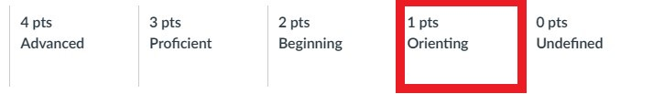

I assess myself as orienting because I have started to consider the societal impact of my individual project, including both its positive and negative effects. The positive impact of my project is helping new artists improve their songs to become top hits. However, there are also potential negative impacts, which I have outlined in my Personal Challenge Proposal document.

I also talked to one of the teachers about the societal impact that I thought about. Some positive and negative impact it could have.

For the group we haven’t thought about it yet.

### Feedback Evidence

Here is the part of the societal impact that I wrote about in my Personal Challenge Proposal document.

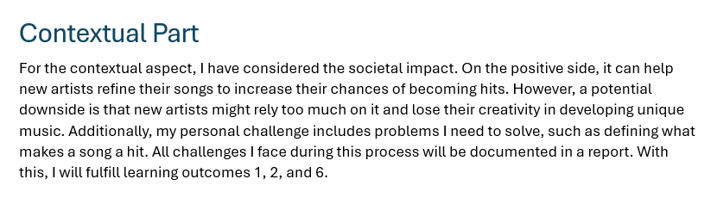

Here is the FeedPulse feedback that I talked to Jacco about my societal impact.

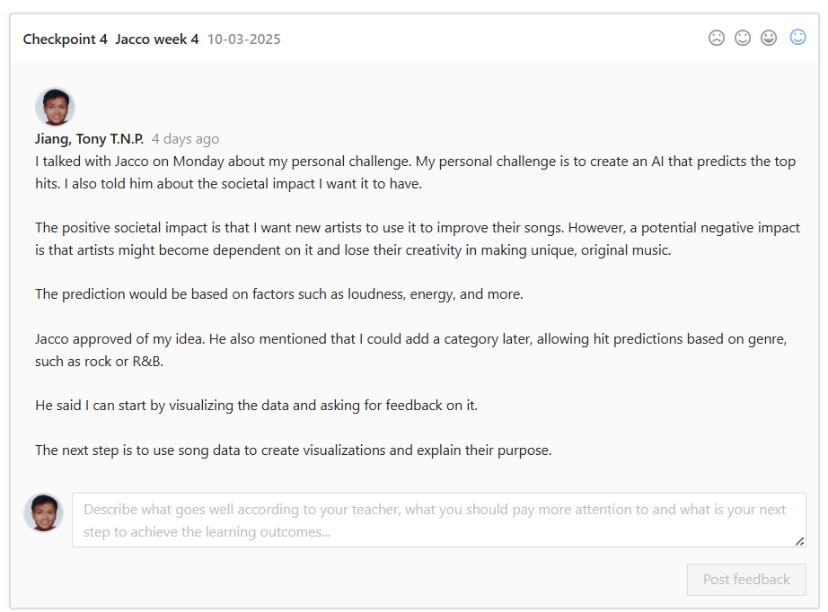

## Second Evaluation: week 8

### Self-assessment

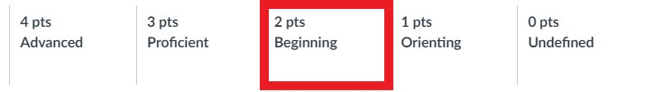

I assess myself as a beginner because I have created a Societal Impact document in which I consider different perspectives on my individual project, such as its potential impact on society, including privacy, data usage, target users, transparency, hateful and criminal actors and other considerations that have to do with Societal Impact. Additionally, I received feedback from Danny that the document was good, and I plan to review it again at the end of the semester to see if my views have changed since I first wrote it.

### Feedback Evidence

Here is the Societal Impact document that I have written for my individual project and below that I the feedback I got from Danny on my Societal Impact document that I need to revisit later on.

[Societal Impact Document](https://stichtingfontys-my.sharepoint.com/personal/457292_student_fontys_nl/Documents/Societal%20Impact%20Document.docx?web=1)

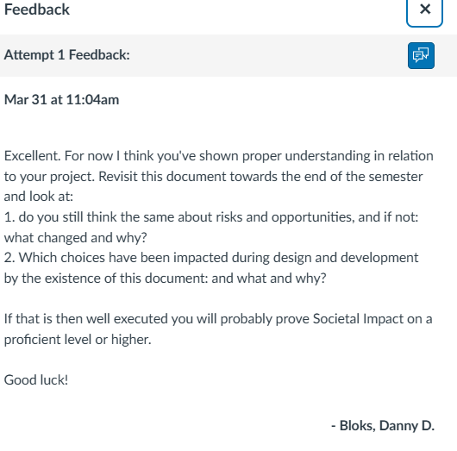

## Third Evaluation: week 12

### Self-assessment



I assess myself as beginning because I still need to revisit the Societal Impact document and evaluate whether there have been any changes since the first version. I also spoke with a legal consultant and received feedback on my individual project, indicating that I need to create a document covering the legal aspects of my personal project.

### Feedback Evidence

Here is the feedback I got from Mara, the legal consultant, which I need to create a document for my individual project about legal coverage.

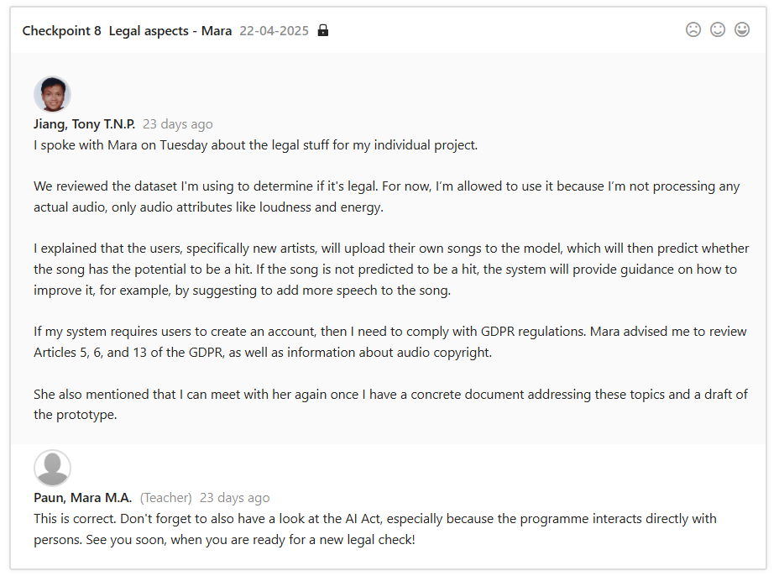

# Learning Outcome 2 investigative Problem Solving

This learning outcome focuses on you to be able to identify problems within your AI project and develop solutions to address them.

## First Evaluation: week 4

### Self-assessment

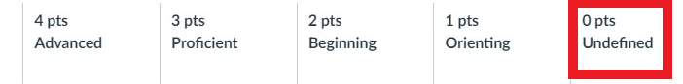

I assess myself as undefined. I have yet to identify problems in my individual project and group project.

### Feedback Evidence

No evidence.

Second Evaluation: week 8

Self-assessment



I assess myself as a beginner because, for my individual project, I created a Societal Impact document where I reflected on potential problems that could arise. For example, if I were to sell my project, an AI model that predicts top hit songs, to a company, it might be used in a way that changes its original purpose. I also proposed a solution to address that issue.

For my group project, we researched a problem by formulating it as a question, writing down the methodology we are going to use from the DOT framework, investigating it, documenting our findings, testing possible solutions, and drawing a conclusion. One example of a problem we explored was: “How can an OpenAI assistant be implemented for the AI Tutor?”

Feedback Evidence

Here is the evidence about the problem I thought about if I sold my individual project and the solution I came up with. It from my Societal Impact document in the “Future” section.

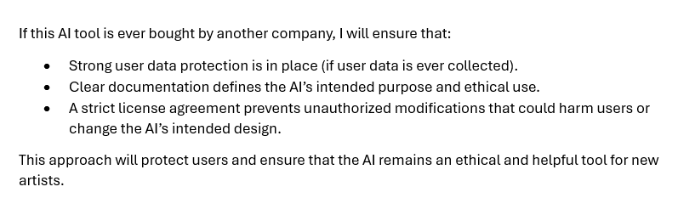

[Societal Impact Document](https://stichtingfontys-my.sharepoint.com/personal/457292_student_fontys_nl/Documents/Societal%20Impact%20Document.docx?web=1)

Here are the research documents we have done for the group.

[**RAG**](https://stichtingfontys-my.sharepoint.com/personal/457292_student_fontys_nl/Documents/RAG.docx?web=1)

[**OpenRouter**](https://stichtingfontys-my.sharepoint.com/personal/457292_student_fontys_nl/Documents/OpenRouter.docx?web=1)

[**OpenAI Assistant**](https://stichtingfontys-my.sharepoint.com/personal/457292_student_fontys_nl/Documents/OpenAI%20Assistant.docx?web=1)

Third Evaluation: week 12

Self-assessment



I assess myself as beginning because there are still some problems with the dataset in my individual project that I don’t yet know how to solve. To address this, I asked for feedback and consulted with the technical teachers.

In the group, problem-solving hasn’t been an issue thanks to my teammates. We define different solutions and validate them by considering various perspectives. For example, version 2 of our architecture was too technical for the client, so we created a third version that was less technical and included explanations. Another example is when we weren’t sure what information we needed for the AI Tutor, so we created a draft class diagram to clearly define the information required for the AI Tutor.

Feedback Evidence

Here is the feedback, where I consult the problem with Jacco the technical teacher.

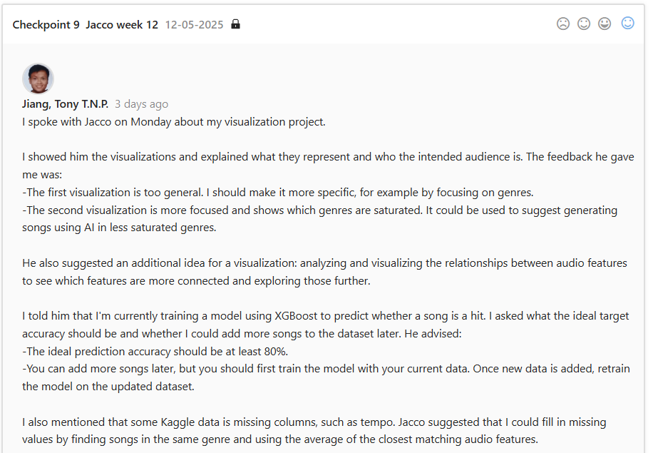

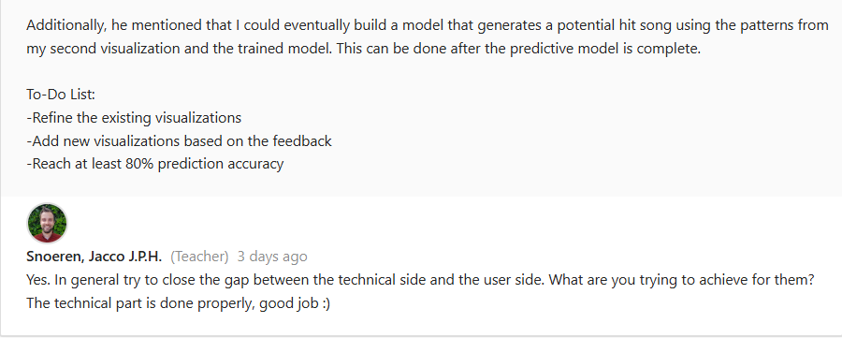

Here is the second version of the architecture, which is very technical.

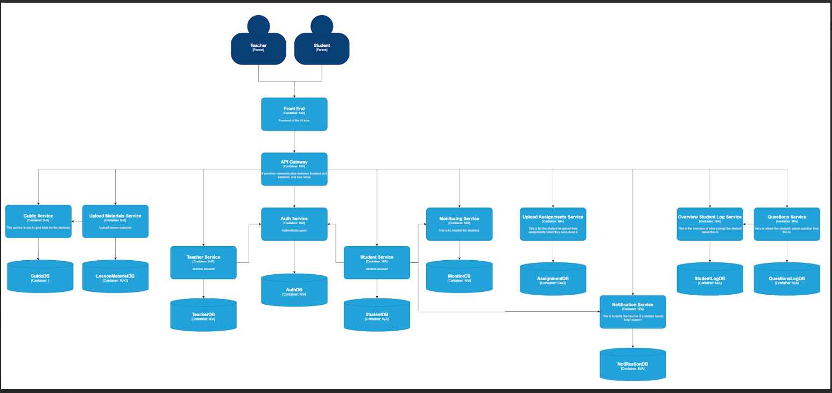

Here is the third version of the architecture, which is more understandable for the client.

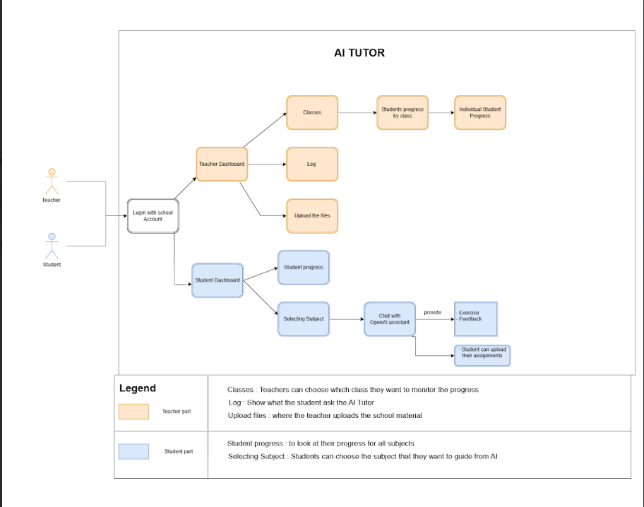

Here is the draft of the class diagram that we made.

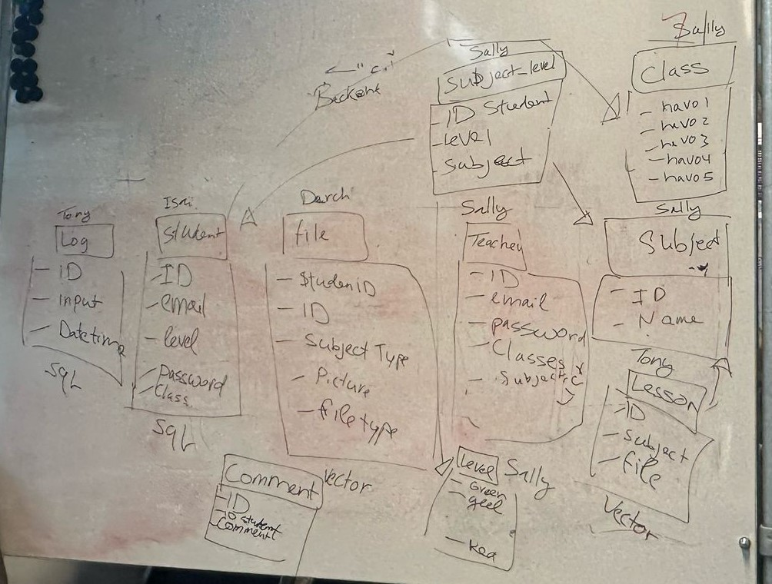

# Learning Outcome 3 Data Preparation

This learning outcome focuses on collecting data, estimating its volume, and using it appropriately in your AI project.

## First Evaluation: week 4

### Self-assessment



I assess myself as orienting because I have explored the data I need for my individual project. Specifically, I analyzed song data for hit song prediction. I examined the attributes that could be useful for prediction, such as the song’s energy, loudness, and other relevant features, instead of using the song's MP3 file.

Additionally, I received feedback from Jacco, who said it’s a good idea.

### Feedback Evidence

Here is the FeedPulse that I had feedback from Jacco after discussing the song data with him, including the attributes I can use for my hit song prediction.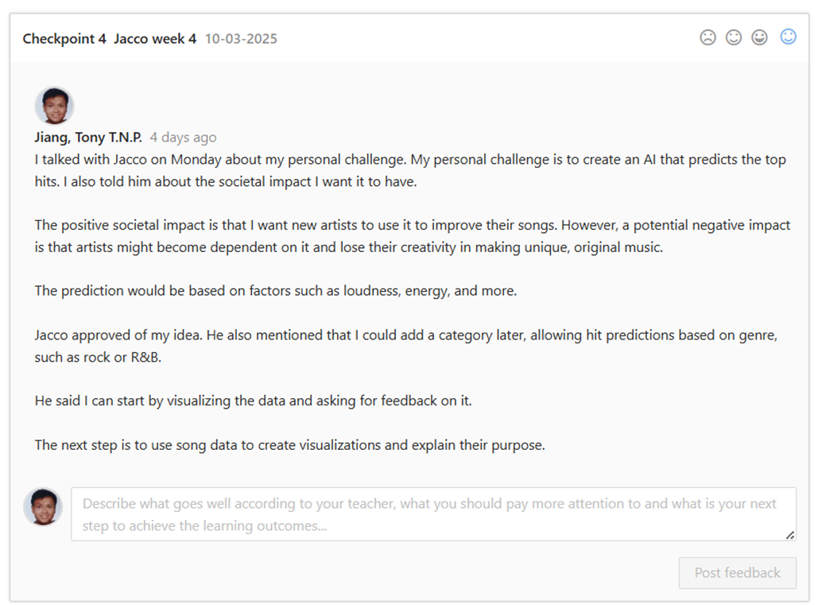

Second Evaluation: week 8

### Self-assessment



I assess myself as a beginner because, in the Societal Impact document, I reflected on data accuracy, the type of data being collected, and how that data is being used. I also cleaned my dataset by removing unnecessary columns and empty entries to ensure they wouldn't interfere with the model training and testing process.

For the group project, we are using exam assignments from examenblad.nl to test the OpenAI assistant, which we are using to build an AI tutor. Since the OpenAI assistant is already pre-trained, we don’t need to train it ourselves instead, we focus on instructing the model on how to work with our specific data. The data that is being uploaded is a PDF, but it can be other file types.

### Feedback Evidence

Here is the evidence that I thought about the data in my Societal Impact document.

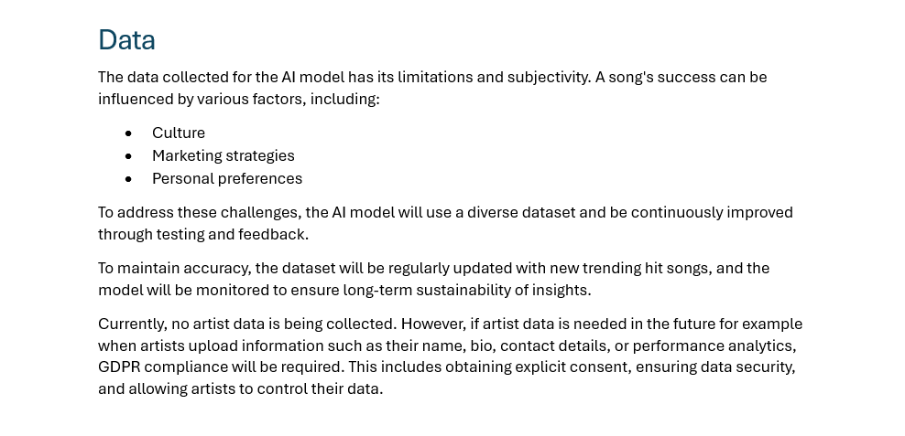

Here is where I clean my data for my individual project.

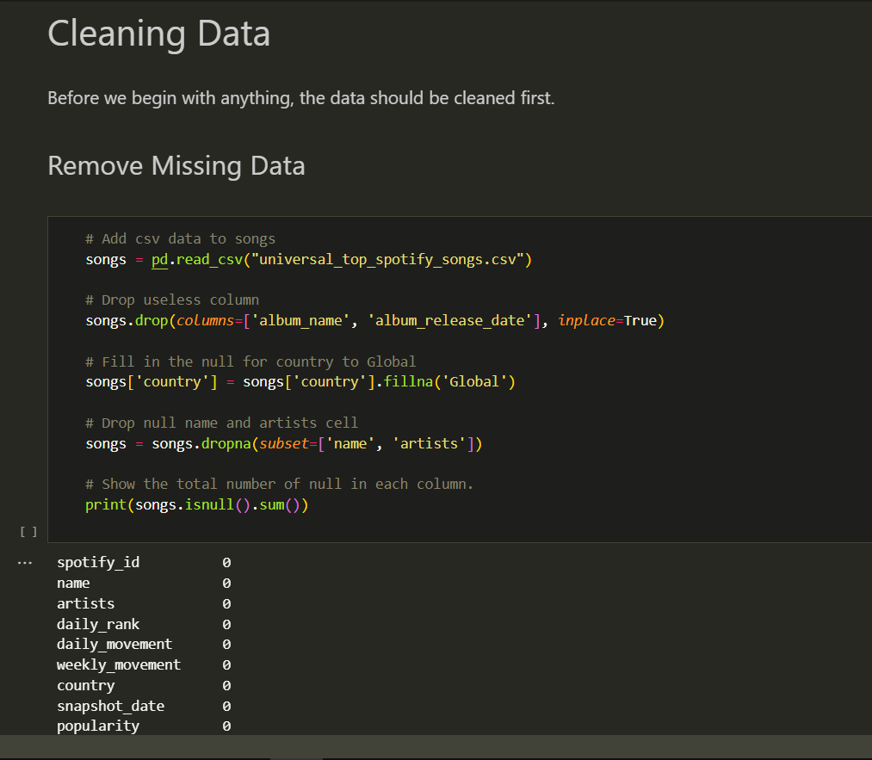

Here is the mention of what you can upload for the OpenAI assistant and give instructions on what to do. Also below is the research document we did on OpenAI Assistant.

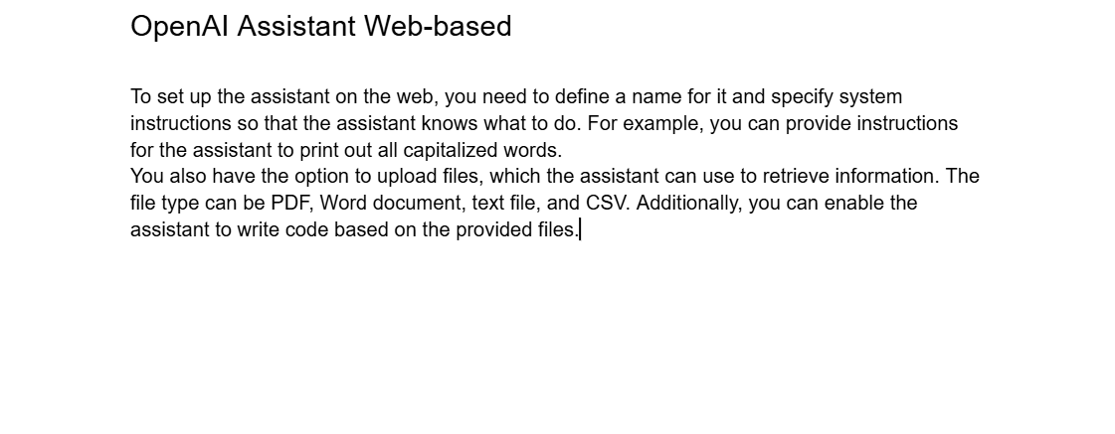

[OpenAI Assistant](https://stichtingfontys-my.sharepoint.com/personal/457292_student_fontys_nl/Documents/OpenAI%20Assistant.docx?web=1)

Third Evaluation: week 12

Self-assessment



I assess myself as beginning because my individual project is still missing a legal document, such as a GDPR document, outlining what user data I’m collecting and how I plan to use it. What I currently have in place is data cleaning, including removing duplicates for both visualization and model training/testing purposes. The data used for visualization is slightly different from the data used by the model, for example, the model does not use the 'track_artist' field, as it has no relevance for prediction but for visualization you can use it. The model is trained on song attributes and predicts whether a song is a hit.

As a group, we are still missing GDPR documentation. The data we are using include PDF files from lessons available on examenblad.nl, from the client, and from a group member who has access to PDF lesson materials provided by a teacher.

Feedback Evidence

Here is the feedback I got from the legal consultant on making a GDPR document.

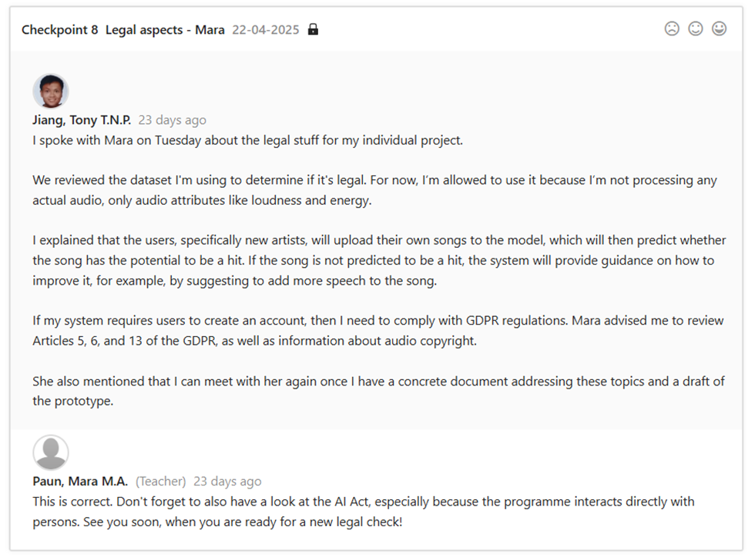

Here are the PDF files for the AI Tutor.

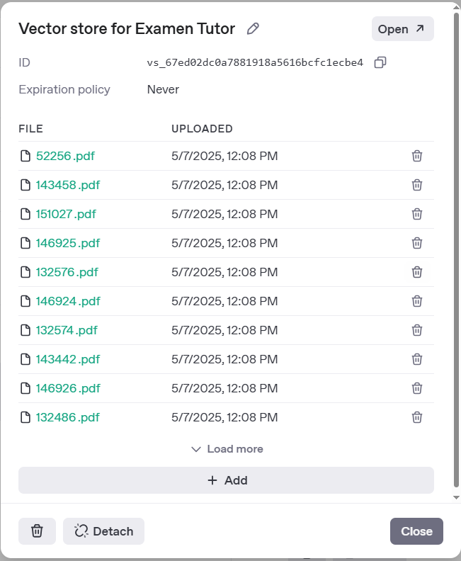

# Learning Outcome 4 Machine Teaching

This learning outcome focuses on training an AI model with the data provided to ensure it serves its intended use. Additionally, it involves testing the model to verify that it has been trained correctly

## First Evaluation: week 4

### Self-assessment



I assess myself as undefined because I haven’t looked into training an AI model for my individual project and group project yet.

### Feedback Evidence

No evidence.

Second Evaluation: week 8

Self-assessment



I assess myself as orienting because, in our group project, we have just started creating a prototype of the AI Tutor using the OpenAI Assistant API. We uploaded exam documents to test the data and see how it works. We gave the model specific instructions on how to use the data and how to respond, in order to better understand how the OpenAI Assistant works and how we could implement it for the AI Tutor. Since the OpenAI Assistant is already trained, we only need to provide it with the specific instructions we want it to follow.

Feedback Evidence

Here is the research document we created on the OpenAI Assistant, explaining how we tested it and evaluated how it works.

[**OpenAI Assistant**](https://stichtingfontys-my.sharepoint.com/personal/457292_student_fontys_nl/Documents/OpenAI%20Assistant.docx?web=1)

Third Evaluation: week 12

Self-assessment



I assess myself as beginning because, in my individual project, I’m currently training my model to reach 80% accuracy. I also discussed this with Jacco.

For the group project, we are currently focusing the AI Tutor on a single subject: English. Based on the test we conducted during the AI event, where visitors at our booth are able to try and break the AI Tutor like a student might, we identified areas that need improvement. We still need to work on making the AI Tutor respond only to questions related to the English lessons provided in the PDF files. It should also be able to answer user questions in different languages.

Feedback Evidence

Here is the feedback when I told Jacco, that I’m currently training my model.

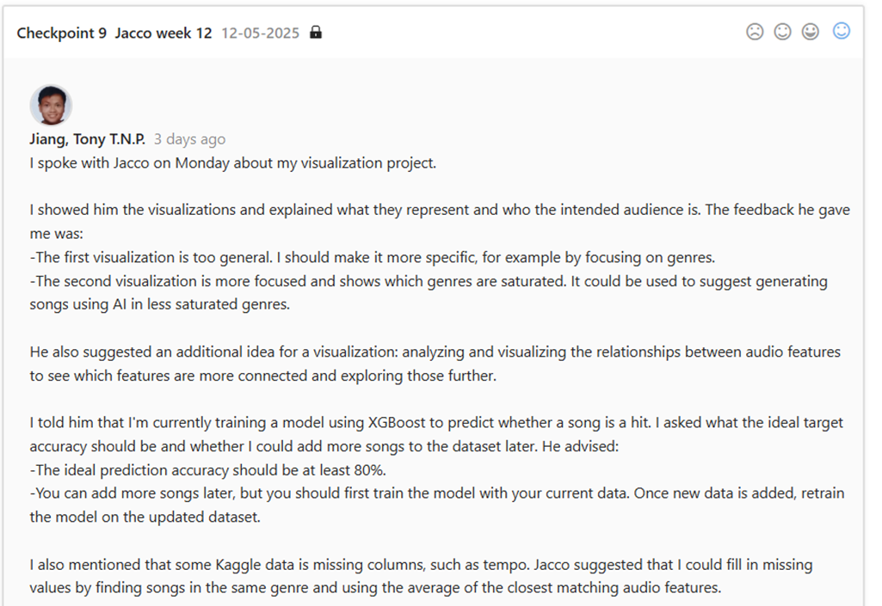

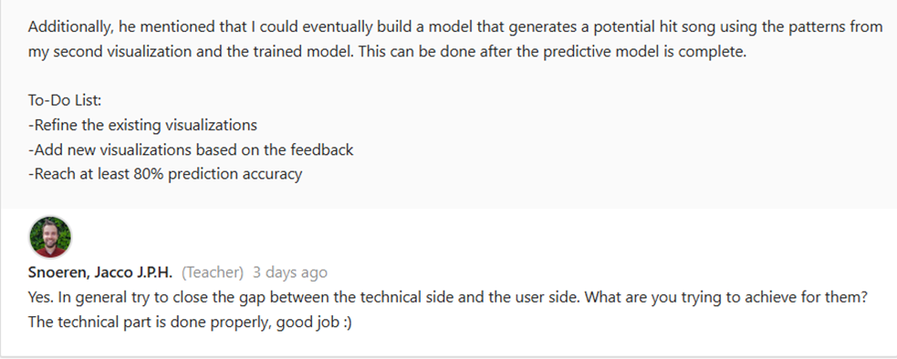

Here is the feedback we have written down on what we need to fix for the AI Tutor during the event.

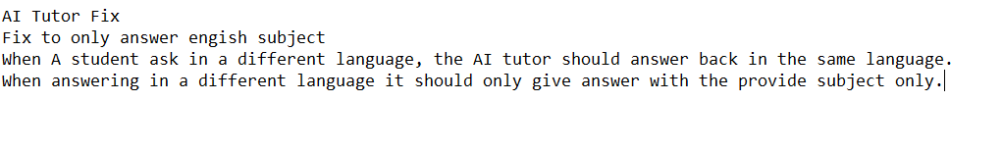

Here is the test of what the audience did on the AI Tutor, that we need to fix.

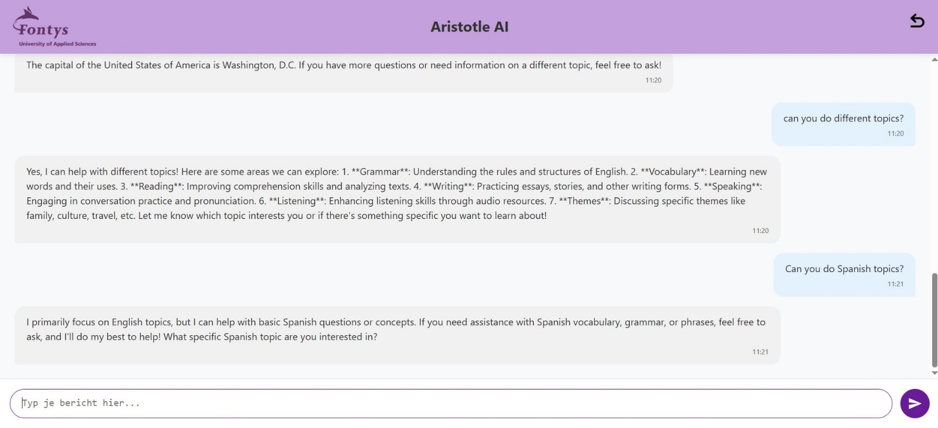

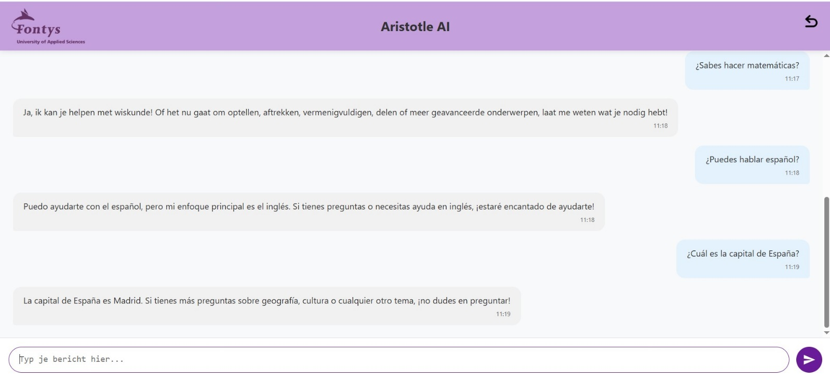

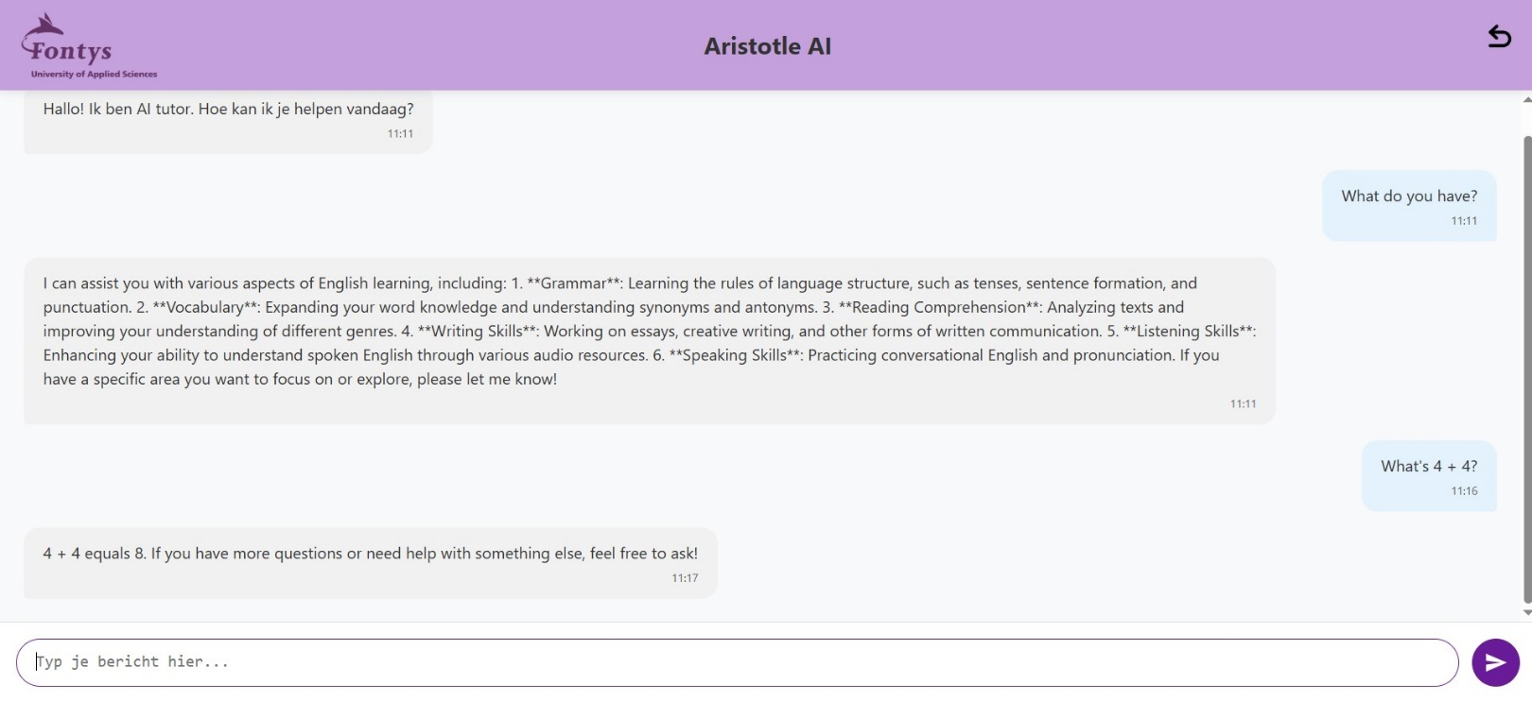

# Learning Outcome 5 Data Visualisation

This learning outcome focuses on presenting data in a meaningful and educational way about the data, allowing the target users to interact with and understand the information that is being displayed.

## First Evaluation: week 4

### Self-assessment



I assess myself as undefined because I have not yet started visualizing my data in a meaningful way for either my individual or group project.

### Feedback Evidence

No evidence.

Second Evaluation: week 8

Self-assessment



I assess myself as orienting because I have just started working on the visualization for my individual project, trying to understand what to visualize in a meaningful way. I also received feedback on my data visualization, on what to fix, what to visualize and how to do it, so now I'm planning how to showcase it effectively and explain why I chose to visualize the data in that way.

Feedback Evidence

Here is the feedback I got from my data visualization.

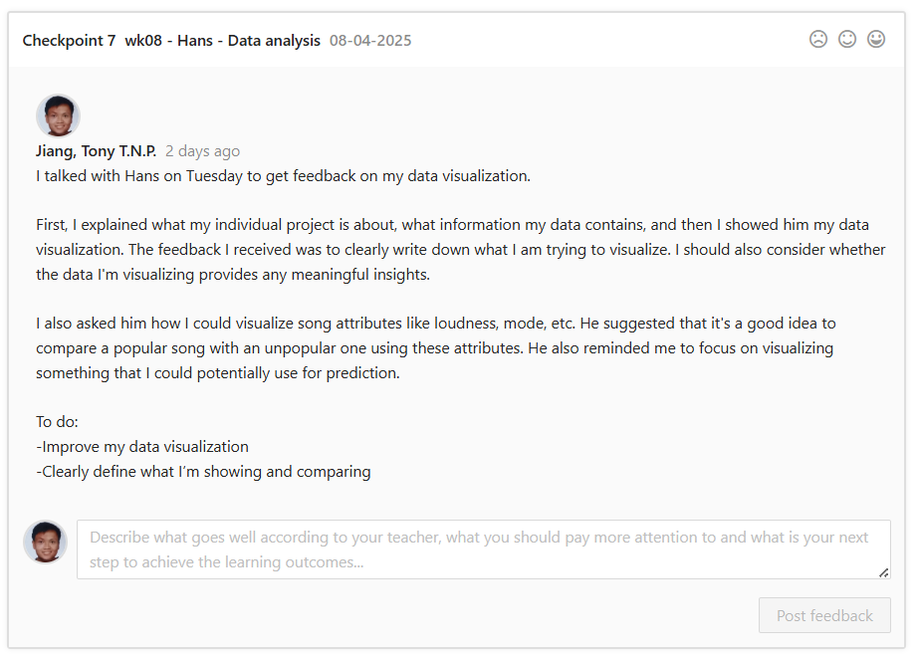

Third Evaluation: week 12

Self-assessment



I assess myself as beginning because, although I now understand what the data visualization does and who it is meant for, I still struggle a bit with deciding what exactly to visualize in my individual project. I created some visualizations and received feedback on what to improve and what to consider.

As for the group project, we created a demo showing how the AI tutor works, highlighting the features that are currently functioning.

Feedback Evidence

Here are the visualizations that I made and got feedback on for my individual project.

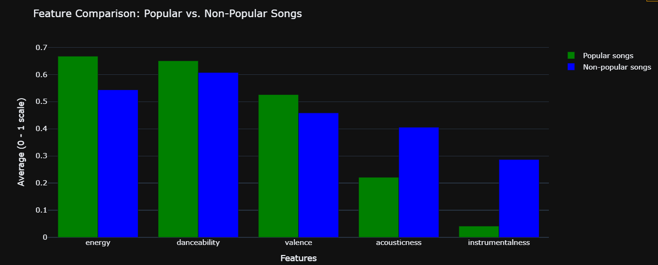

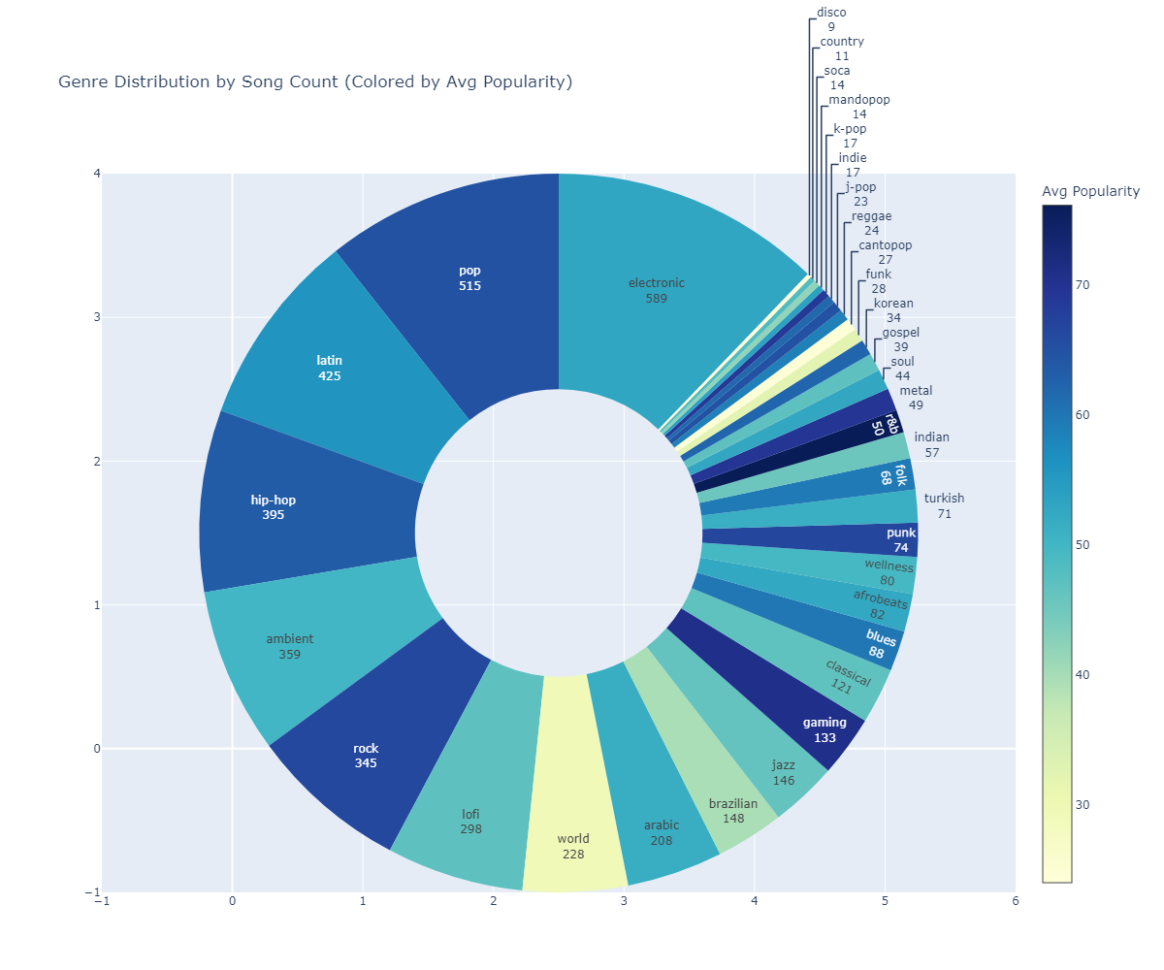

Here is the feedback I got from Jacco about my visualization

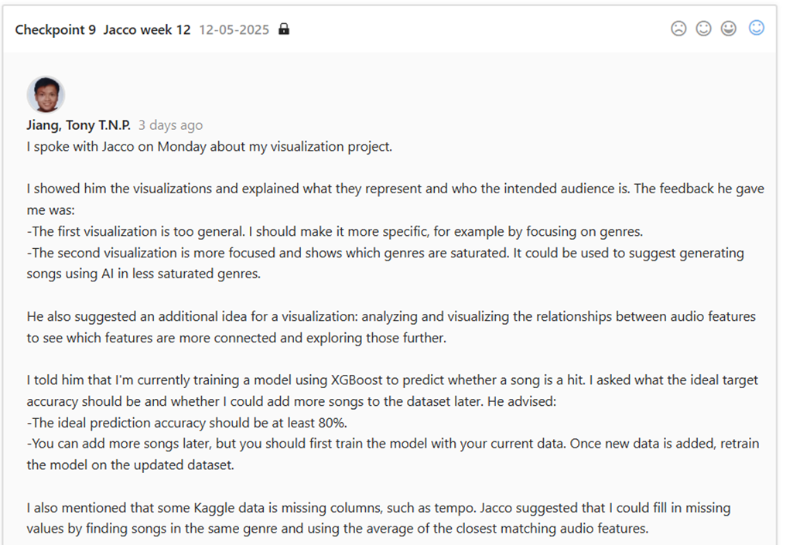

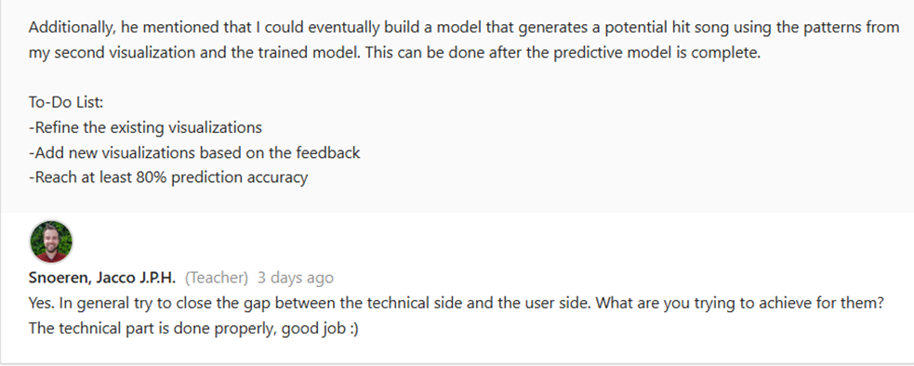

Here is the video demo of the group project.

<https://stichtingfontys-my.sharepoint.com/:v:/g/personal/457292_student_fontys_nl/EfvvklgYYdRBqd8gvvsc9igB4ZYKLD_tt0LIRCKl3HjnZw?nav=eyJyZWZlcnJhbEluZm8iOnsicmVmZXJyYWxBcHAiOiJPbmVEcml2ZUZvckJ1c2luZXNzIiwicmVmZXJyYWxBcHBQbGF0Zm9ybSI6IldlYiIsInJlZmVycmFsTW9kZSI6InZpZXciLCJyZWZlcnJhbFZpZXciOiJNeUZpbGVzTGlua0NvcHkifX0&e=ntiI69>

# Learning Outcome 6 Reporting

This learning outcome focuses on creating a report about your AI project or group project in a best-practice manner. The reporting can be from project proposals, process documentation, etc.

## First Evaluation: week 4

### Self-assessment



I assess myself as orienting because for my individual, I have created a Personal Challenge Proposal outlining what I want to do for my individual project. I also asked Jacco for feedback to ensure my idea is feasible.

For the group project, we created a Group Project Proposal, which is currently in draft form. We have already asked Danny for feedback on areas for improvement. Currently, the proposal is under review by the client.

### Feedback Evidence

Here is the FeedPulse where I have talked to Jacco about my Personal Challenge Proposal.

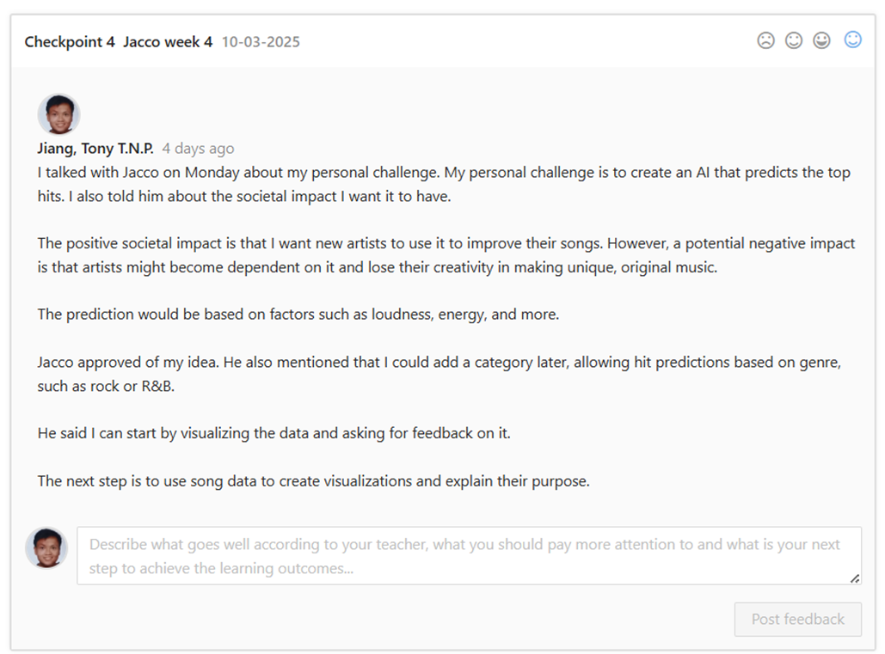

Second Evaluation: week 8

Self-assessment



I assess myself as beginning because, in addition to having a Personal Challenge Proposal for my individual project, I also created a Societal Impact document. In it, I reflected on how my project could impact society both positively and negatively, and I considered how to prevent any negative impacts. Additionally, I received feedback that the document is good, and I plan to revisit it by the final delivery to see if my views have changed or remained the same.

For the group project, we created a Group Project Proposal for ourselves, the clients, and the teachers, to ensure everyone is aligned on what needs to be done this semester. We also created a User Stories document, a Front-End Paper Prototype (wireframe), and a research document where we investigated a specific problem and explored possible solutions.

Feedback Evidence

Here is the Societal Impact document for my individual project and the feedback for it.

[Societal Impact Document](https://stichtingfontys-my.sharepoint.com/personal/457292_student_fontys_nl/Documents/Societal%20Impact%20Document.docx?web=1)

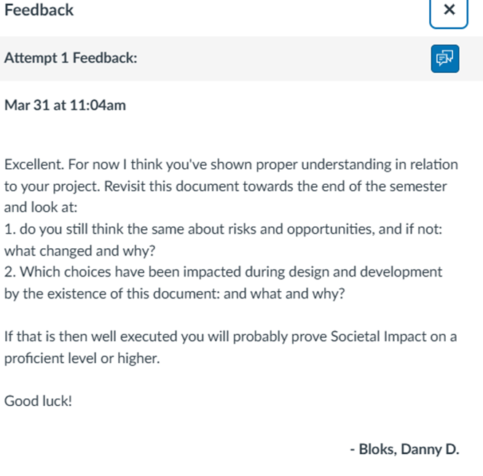

Here are documents from the group project that I mention.

[Group Project Proposal - AI Tutor](https://stichtingfontys-my.sharepoint.com/personal/457292_student_fontys_nl/Documents/Group%20Project%20Proposal%20-%20AI%20Tutor.docx?web=1)

[User Stories](https://stichtingfontys-my.sharepoint.com/personal/457292_student_fontys_nl/Documents/User%20Stories.docx?web=1)

[Front-end paper prototype](https://stichtingfontys-my.sharepoint.com/personal/457292_student_fontys_nl/Documents/Front-end%20paper%20prototype.docx?web=1)

Here are the research documents from the group.

[RAG](https://stichtingfontys-my.sharepoint.com/personal/457292_student_fontys_nl/Documents/RAG.docx?web=1)

[OpenRouter](https://stichtingfontys-my.sharepoint.com/personal/457292_student_fontys_nl/Documents/OpenRouter.docx?web=1)

[**OpenAI Assistant**](https://stichtingfontys-my.sharepoint.com/personal/457292_student_fontys_nl/Documents/OpenAI%20Assistant.docx?web=1)

Third Evaluation: week 12

Self-assessment



I assess myself as beginning because, for my individual project, I’m still missing a GDPR document. I also need to go back and review my Societal Impact document to see if there are any changes after creating the prototype. The Jupyter Notebook is still a work in progress.

For the group project, I’m still missing the GDPR document and a handover document. However, we have recently created a new report: the Architecture Design document, and we also developed a class diagram for the AI Tutor.

Feedback Evidence

Here is the group document.

[Architecture Design](https://stichtingfontys-my.sharepoint.com/personal/457292_student_fontys_nl/Documents/Architecture%20Design.docx?web=1)

Here is the Class diagram for the group.

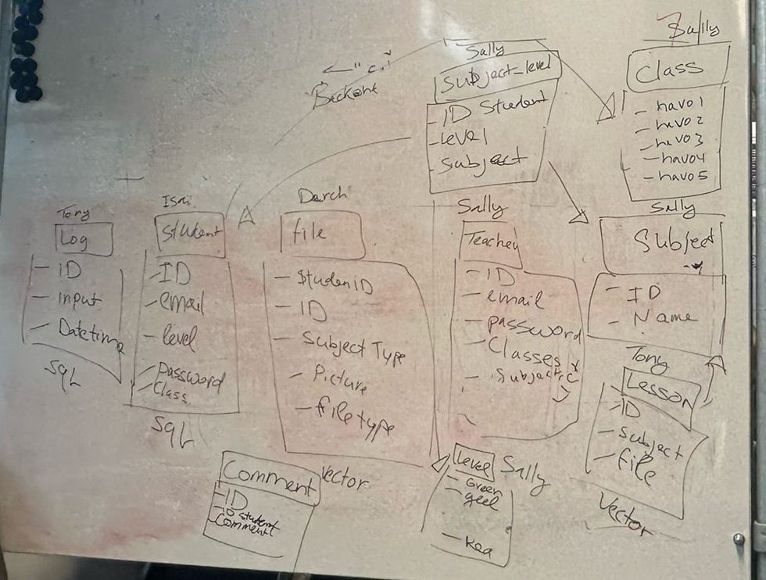

# Learning Outcome 7 Personal Leadership

This learning outcome is about innovating, problem-solving, adaptability and taking initiative in your personal AI project, the group project and personal development. Additionally, it emphasizes on being aware of how much you can learn and keeping your professional goal in mind for your future work field.

## First Evaluation: week 4

### Self-assessment



I assess myself orienting because I have taken the initiative in my individual project by seeking feedback and consulting teachers on how to begin and what to consider. I asked for guidance on where to find data online and whether my project idea was feasible. Initially, I was unsure where to start, but after discussing my ideas, reflecting, and receiving feedback from the teachers, I was able to define a project that I wanted to create.

Before joining a group project, my groupmate Le Thi Thuy (Sally) and I worked together to come up with an idea for the ideation project. We discussed the project's problem, goal, advantages, disadvantages, and other relevant aspects. After the discussion we created an ideation document for the idea we had discussed.

For the group project, we have thought about our priorities, what tasks to complete first, and the time constraints we must consider before the end of the semester. We have outlined our plans for this semester in the Group Project Proposal. We had feedback from Danny on what to improve on the Group Project Proposal and currently it’s in review with the client.

### Feedback Evidence

Here is some feedback from FeedPulse that I had discussed with the teachers about the individual project.

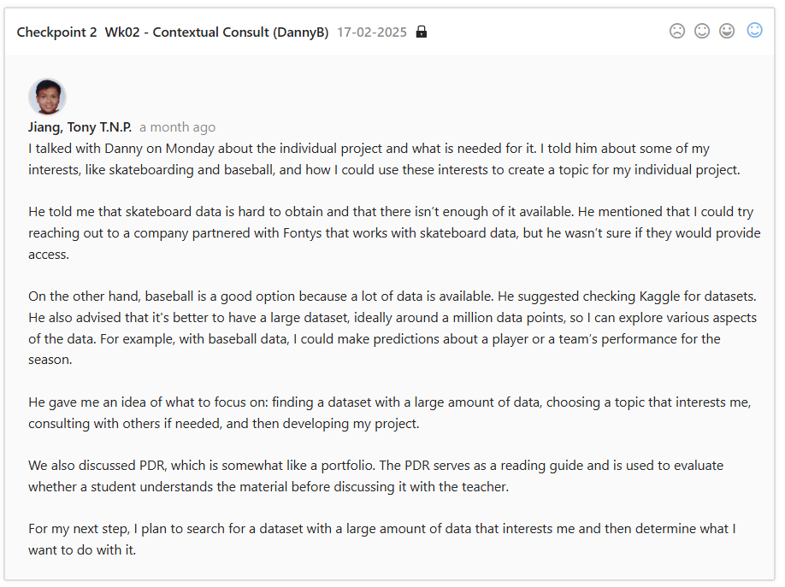

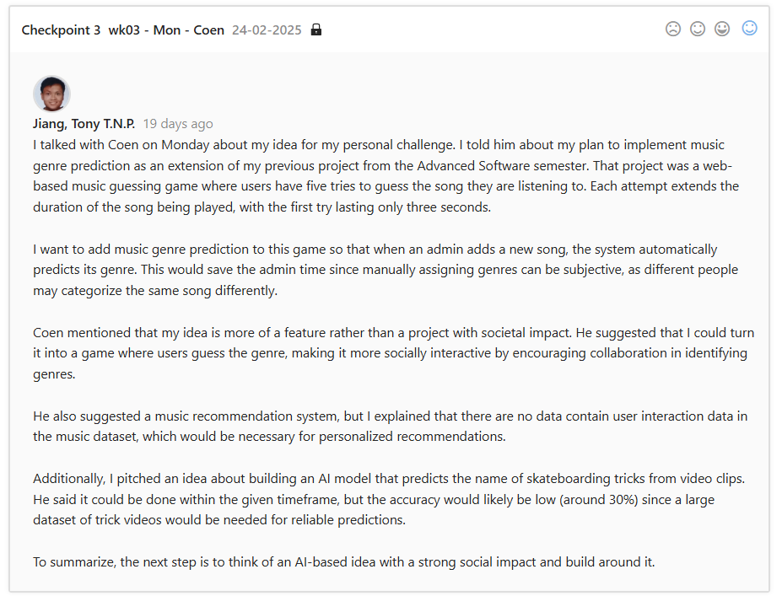

Here is a snippet of the ideation document that we created.

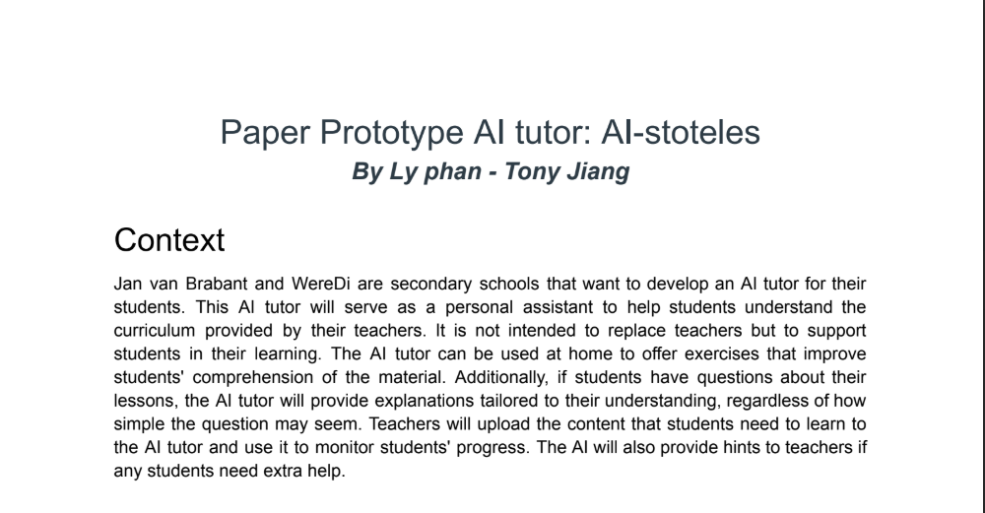

Second Evaluation: week 8

Self-assessment



I assess myself as beginning because I actively seek feedback and talk to the teachers when something is unclear, such as getting feedback on documentation, understanding how things work, or technical stuff like: what to consider when creating data visualizations and their purpose.

Creating the Societal Impact document was new to me, and I wasn’t sure if I had written it correctly or fully considered how my individual project might affect society. So, I worked on the document and gained a better understanding that there is a lot to consider, such as privacy and how a project can impact a person’s life. After that, I took the initiative to ask for feedback to see if I had missed anything.

As a group, we also took the initiative to ask for feedback from both our clients and our group coach on the work we completed. For example, we created an architectural design of the AI Tutor for our group project and presented it to Danny, our group coach, to get feedback before showing it to the client.

Additionally, we created a research document to outline the problem we identified, how we investigated it, and the solution we developed.

Feedback Evidence

Here is the recent feedback on how to get feedback on documentation and about the data visualization example.

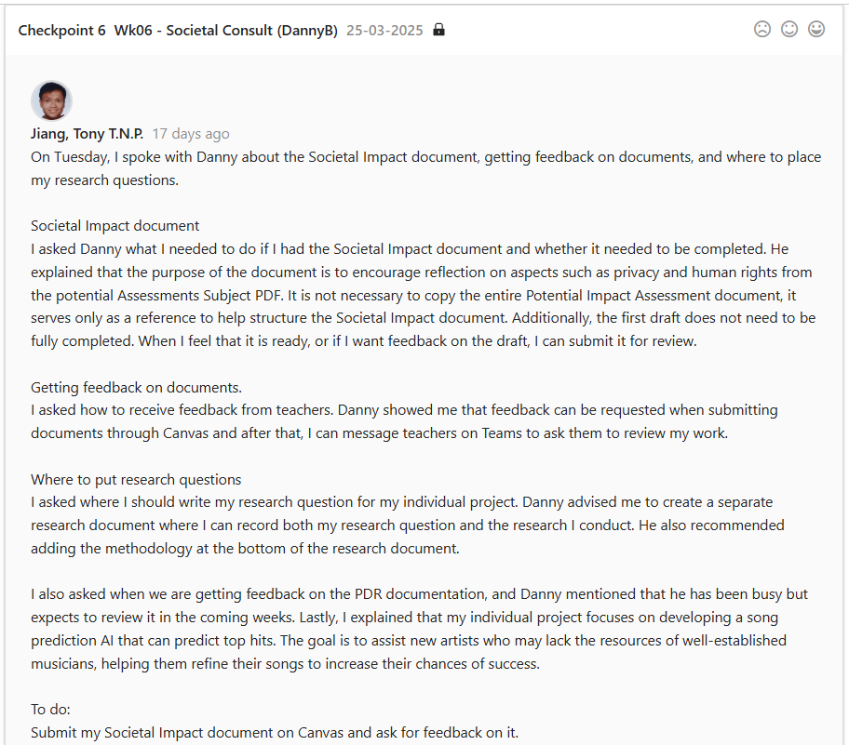

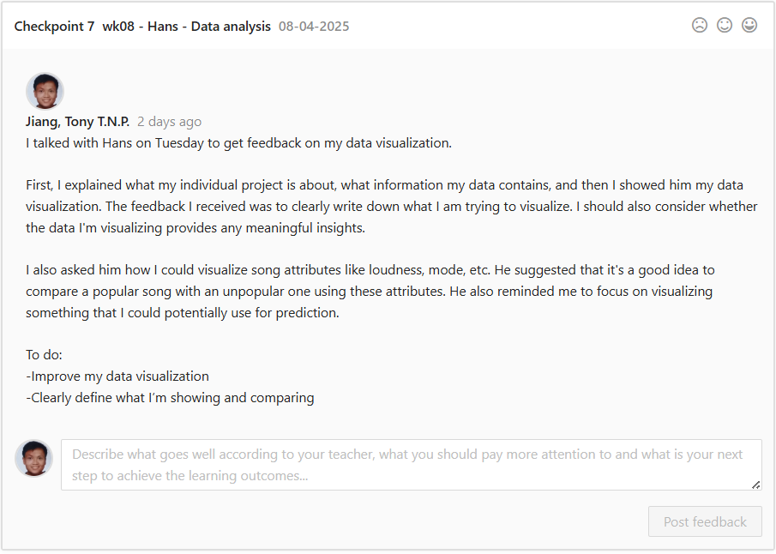

Here is the first version of architecture design of the AI Tutor we showed and explained to Danny and got feedback on it, that it’s good and clear for the client.

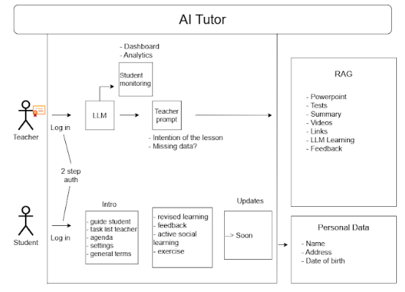

Here is getting feedback from the client when we ask for feedback on the second version of the architecture design of the AI Tutor.

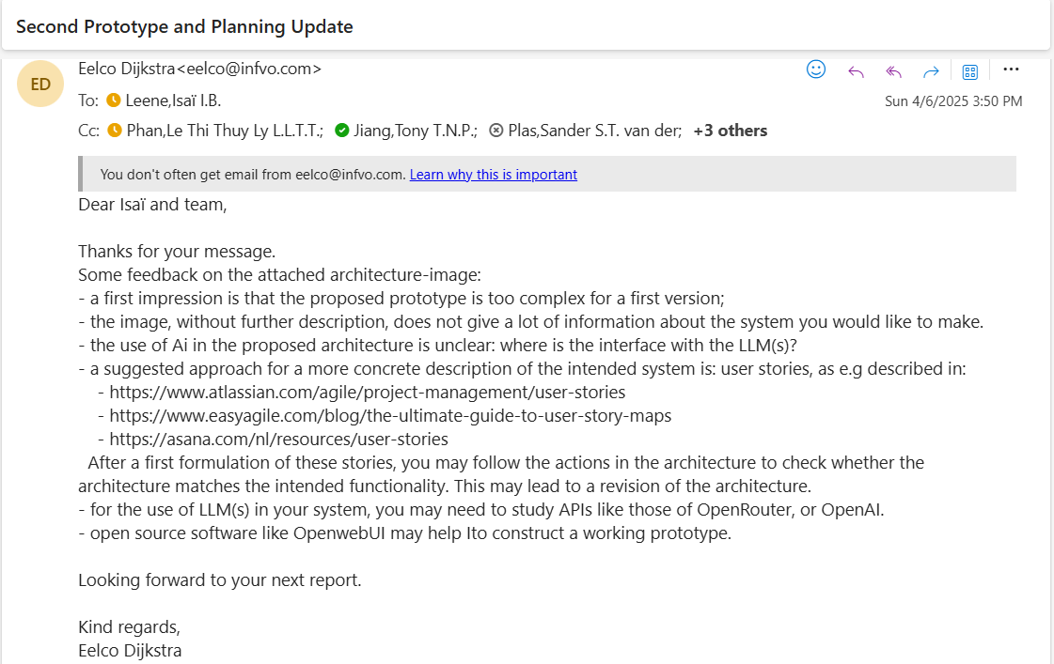

Here are the research documents we did for the group.

[RAG](https://stichtingfontys-my.sharepoint.com/personal/457292_student_fontys_nl/Documents/RAG.docx?web=1)

[OpenRouter](https://stichtingfontys-my.sharepoint.com/personal/457292_student_fontys_nl/Documents/OpenRouter.docx?web=1)

[**OpenAI Assistant**](https://stichtingfontys-my.sharepoint.com/personal/457292_student_fontys_nl/Documents/OpenAI%20Assistant.docx?web=1)

Third Evaluation: week 12

Self-assessment

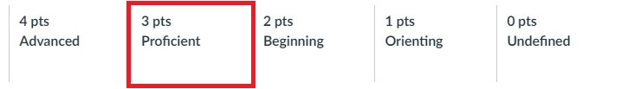

I assess myself as proficient because I actively seek feedback when I have questions or when something is unclear in my individual project. I keep the teachers informed about my progress and I add a “to do” tasks to the feedback I receive, showing what my next steps will be.

For the group project, we hold a stand-up meeting every Monday where we outline our tasks for the week and divide them among group members. We also try to keep Danny updated on our progress and ask for feedback on how we’re doing. Additionally, we conducted a peer feedback session where we highlighted each other’s strengths and areas for improvement for each other to better improve ourselves. Every two weeks, we try to schedule a meeting with the client to present our progress. If we have questions in the meantime, we reach out to him via email.

Feedback Evidence

Here is the recent feedback I got. As you can see there is the” to do”, letting the teacher know what’s my next plan.





Here are the tasks that we divided on Monday this week during the standup meeting.

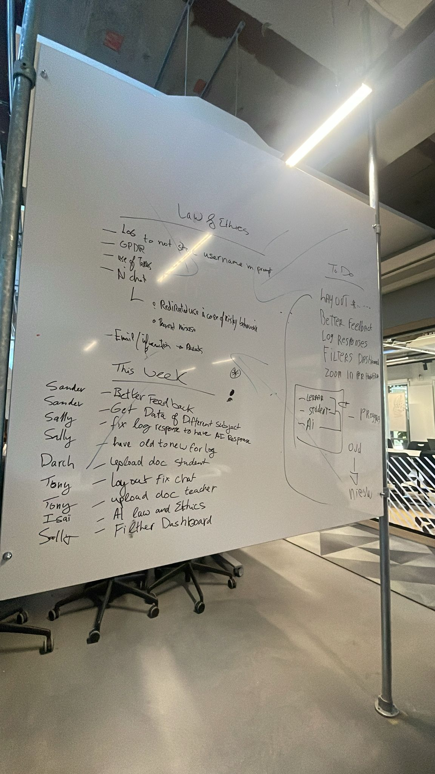

This is the feedback we got from Danny for the group.

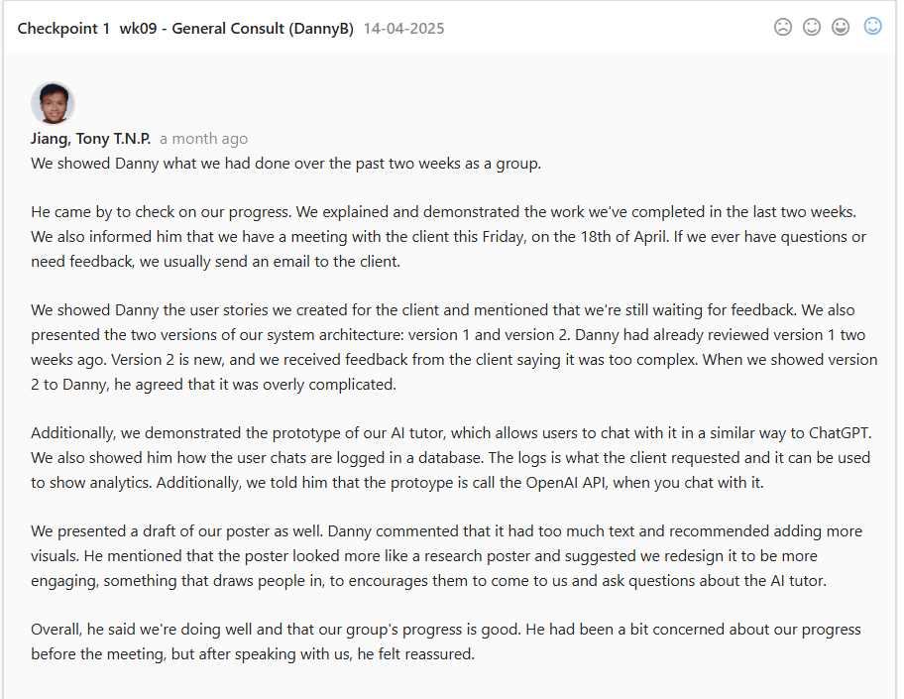

Here is the peer feedback we did.

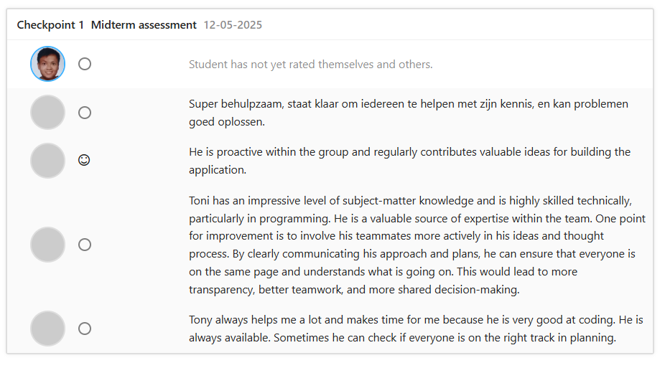

# Learning Outcome 8 Personal Goal

This learning outcome is about defining your own goals for your future field of work. It serves as your personal challenge for growth and development.

## First Evaluation: week 4

### Self-assessment



I assess myself as orienting because I have defined my personal goal in my Personal Challenge Proposal. I have reflected on what I want to learn from AI for Society and how I can apply it to my future work.

### Feedback Evidence

Here is the part where I define my personal goal in my Personal Challenge Proposal.

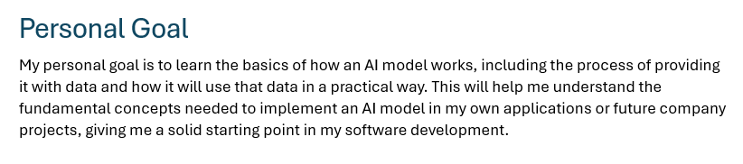

Second Evaluation: week 8

Self-assessment



I assess myself as beginning because I now have some basic knowledge on how to work with data and what societal impact to consider when building an AI tool, with this I’m learning the process of implementing an AI.

For the data, I’m currently working on data visualization. I have already prepared the data by cleaning it and removing unnecessary entities. I now know how to start working with the data; I just need to decide how to visualize it and what aspects to focus on. I received feedback on my data visualization and now need to reflect on it and clearly explain what I’m trying to visualize.

For the societal impact, I’ve learned that when building something with AI, in my case, using an AI tool to predict top hits, it’s important to consider the societal impact of what you create. So, when I create my own product for a future company, I’ll make sure to reflect on it and document its societal impact. The feedback I received on my Societal Impact document shows that I’ve thought thoroughly about my personal project. Now, I just need to revisit the document later to see if any changes are needed.

Feedback Evidence

Here is the feedback I got on how to fix and understand what I need to visualize for my data to understand the process of making visualization.

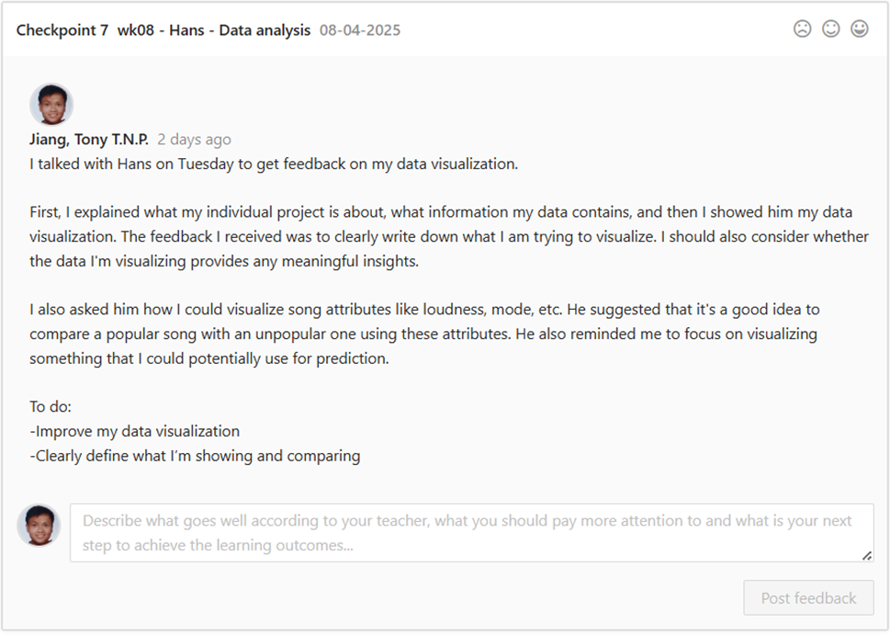

Here is the feedback that I understand the societal impact and I know what to consider when building my own AI for future company.



Third Evaluation: week 12

Self-assessment



For the group project, I contributed to the first version of the poster and received feedback on it. I learned that the initial version looked more like a research poster rather than one designed to attract an audience and invite questions about the project. It also contained too much text and was missing the planning section.

Additionally, during the AI event, I learned how to explain and present the group product in a clear and understandable way, since not everyone in the audience has a technical background. I focused on explaining things in simple terms, but if someone asked a technical question, I responded in a more technical manner. When one of my group members didn’t know how to answer a technical question, I would step in to help. This taught me how to collaborate effectively and support each other when interacting with the audience.

Feedback Evidence

Here is the poster version 1.

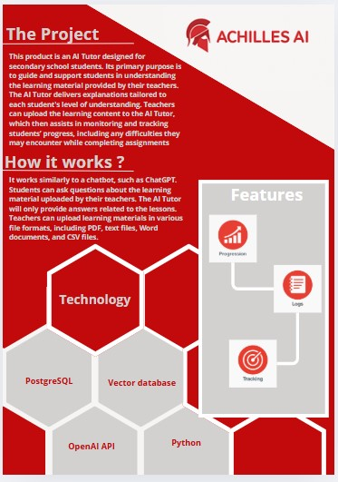

Here is the feedback from Danny about the poster.

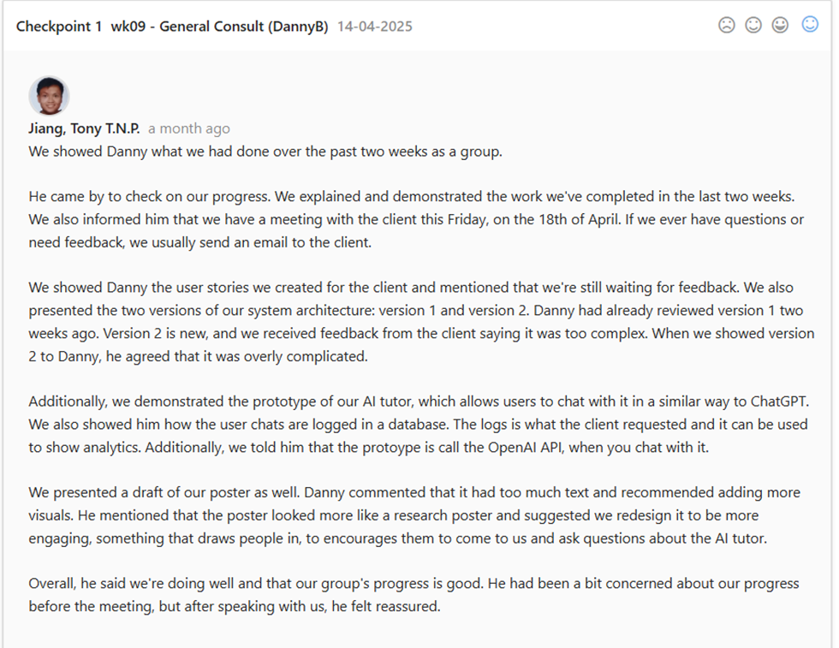

This is our booth.

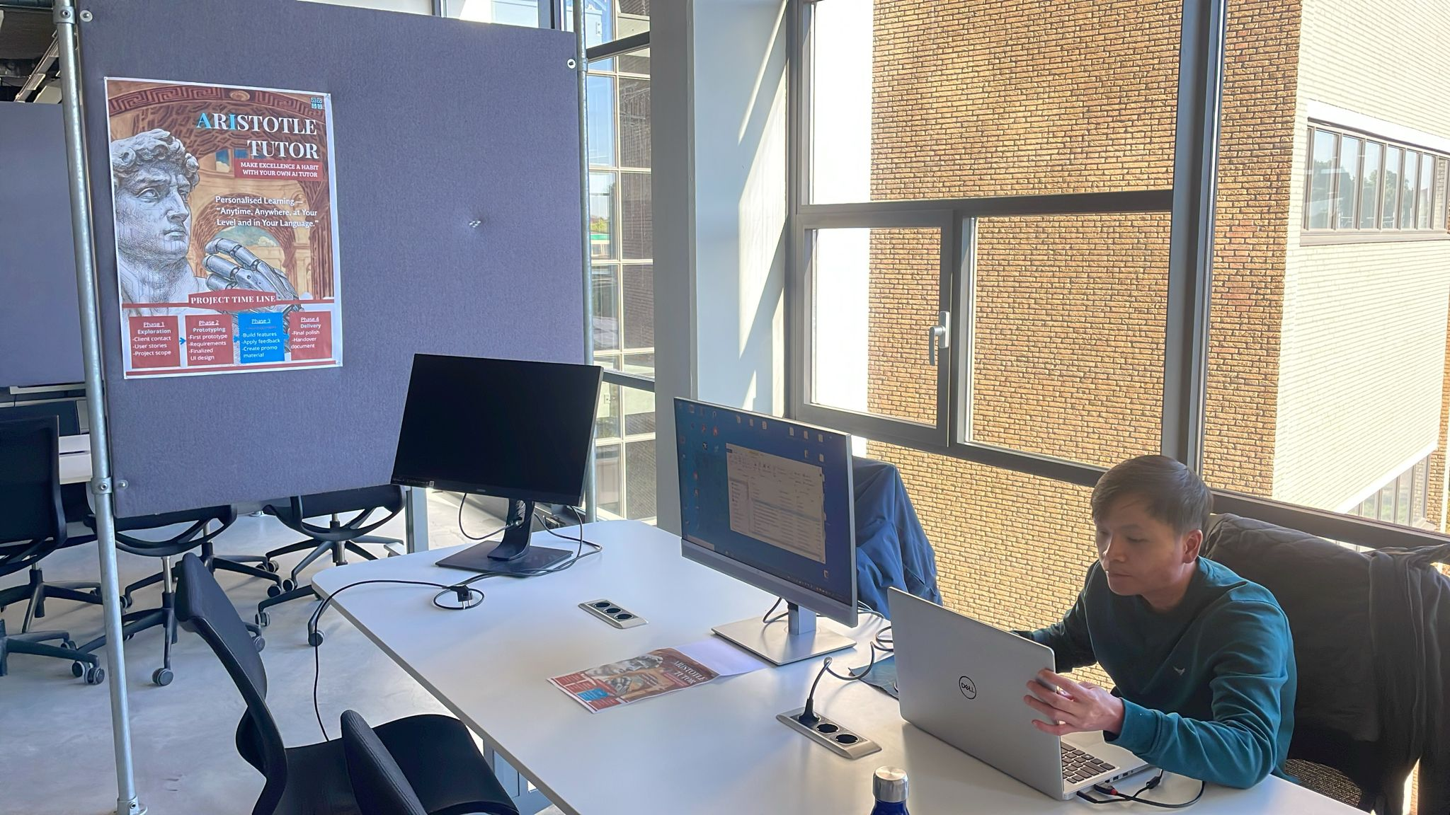

# Retrospective

*Fill in for the final version.*

# Conclusion

*Fill in for the final version.*